**1.Deploy the custom image with any application installed**

For custom image creation in , first we connect to the vm

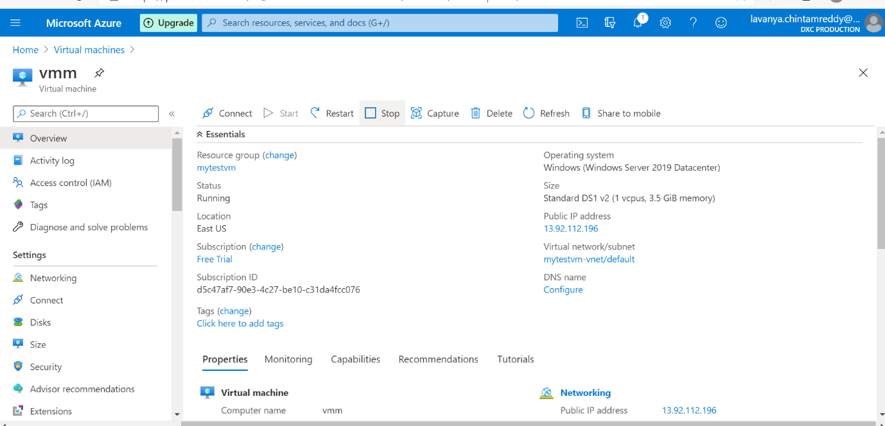

After connecting,we install the application nothing but we create image in vm

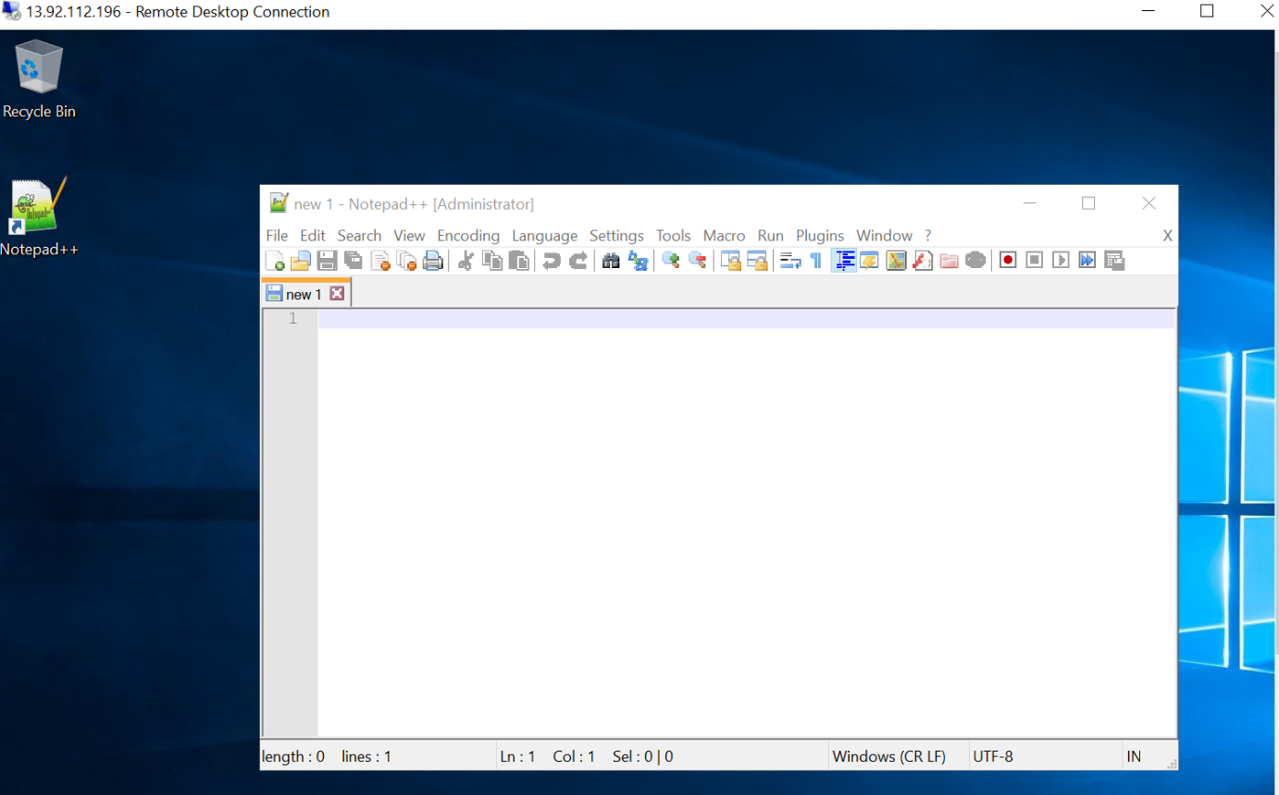

Sysperp for vm image deployment and shutting down the existing vm

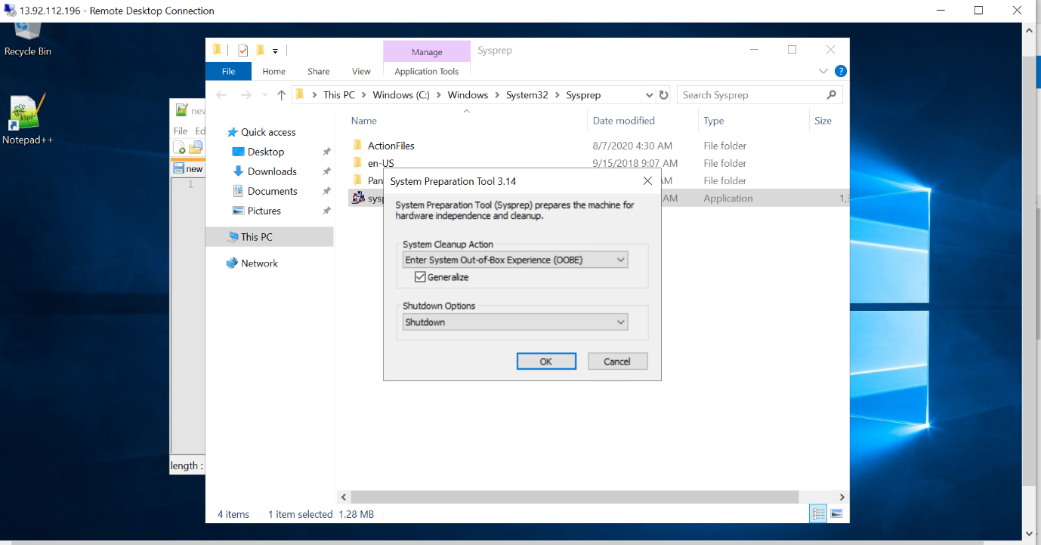

Create an image in vm

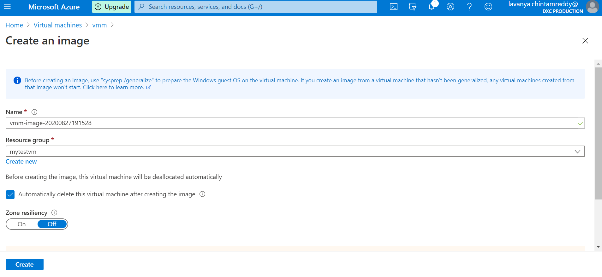

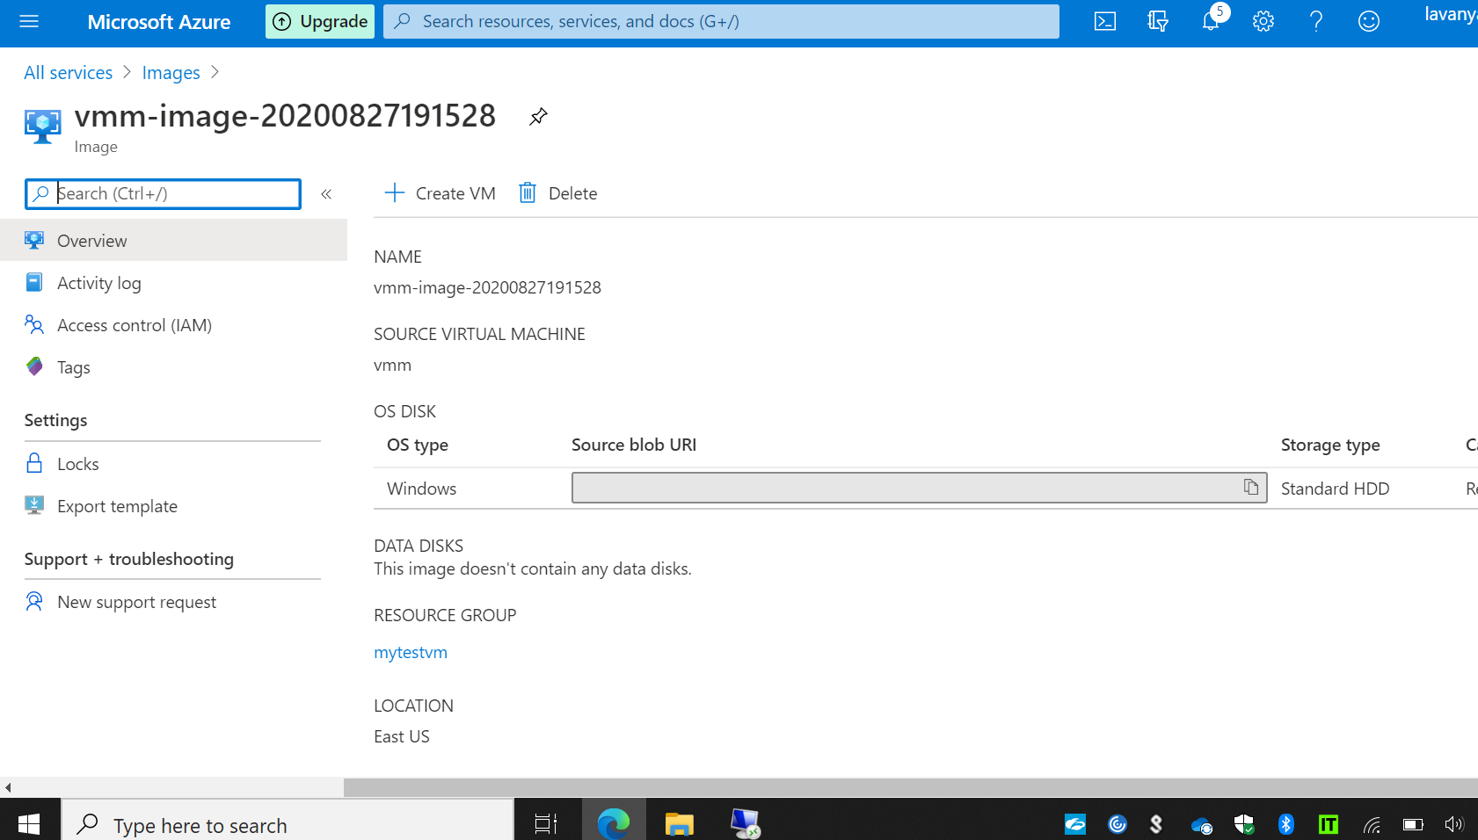

In vm image ,we create the vm and select the custom image, start the vm it displays the application

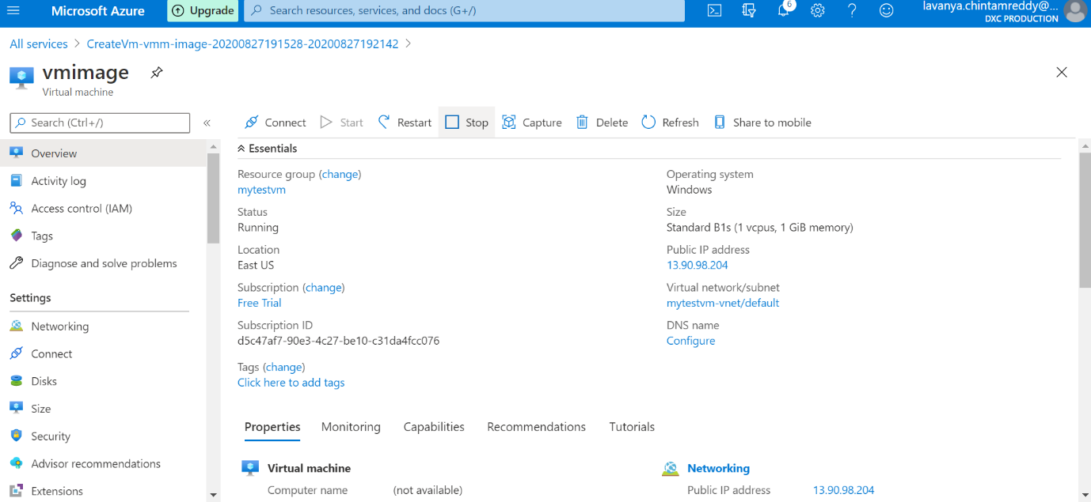

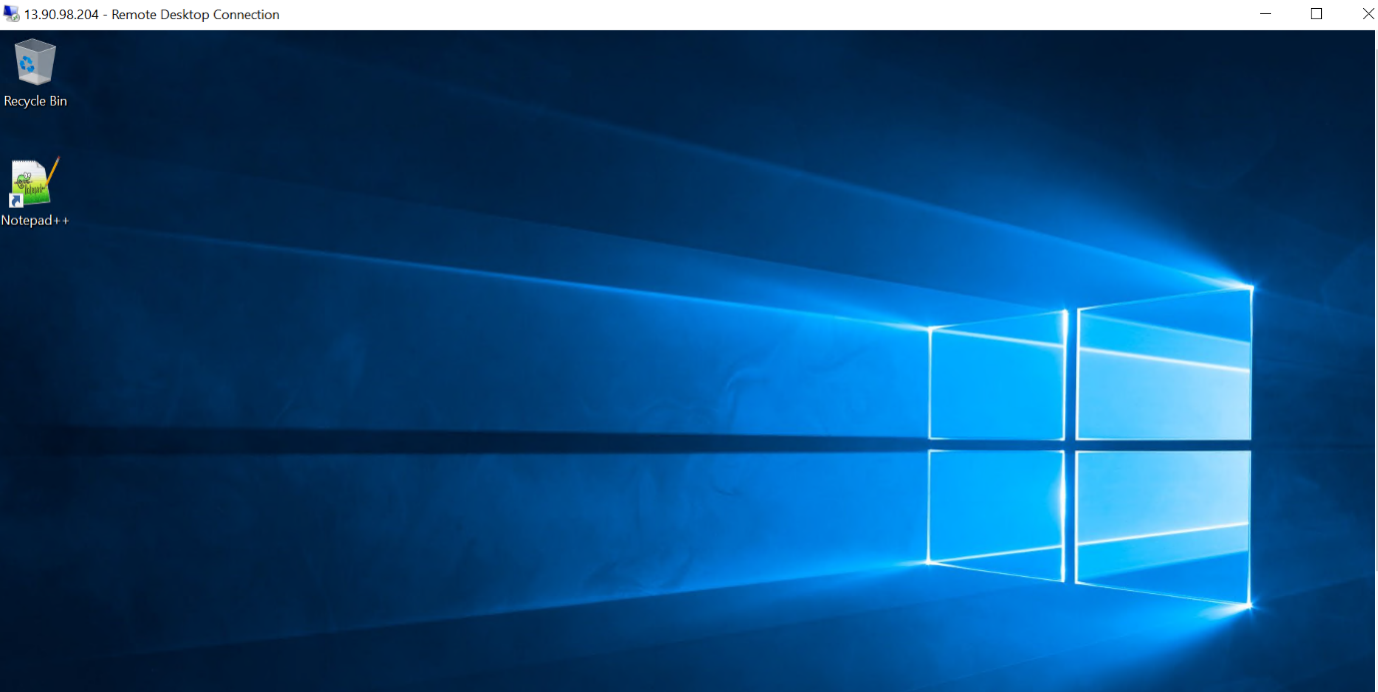

**2.** **Create a two networks in East Asia and west us and peer the network using Network Peering and access the VM using private from one location to other location**

Created a vm in East Asia

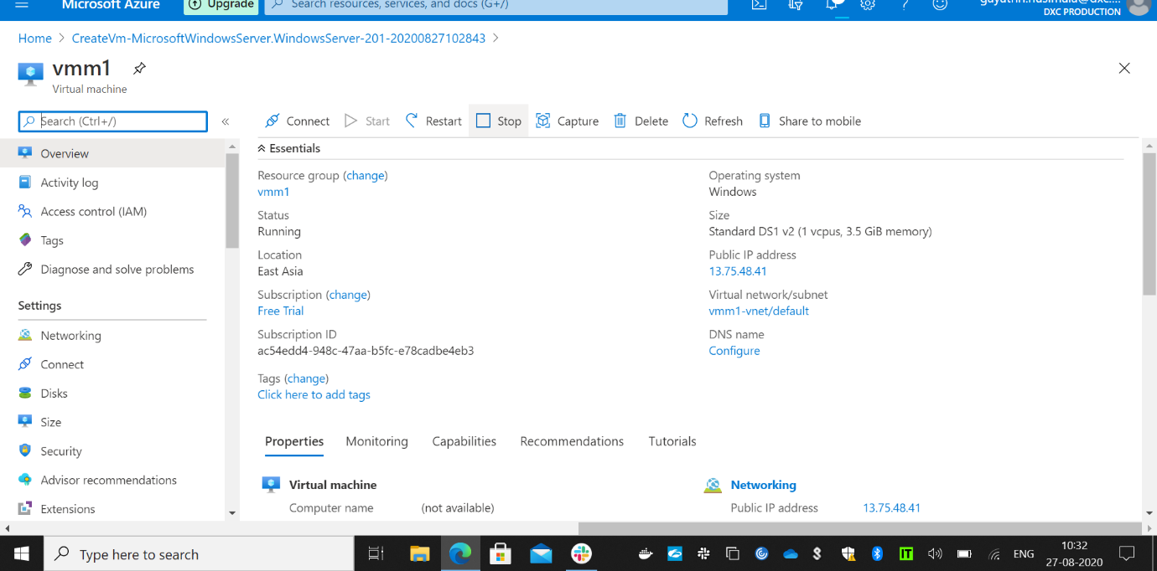

Created vm in West US

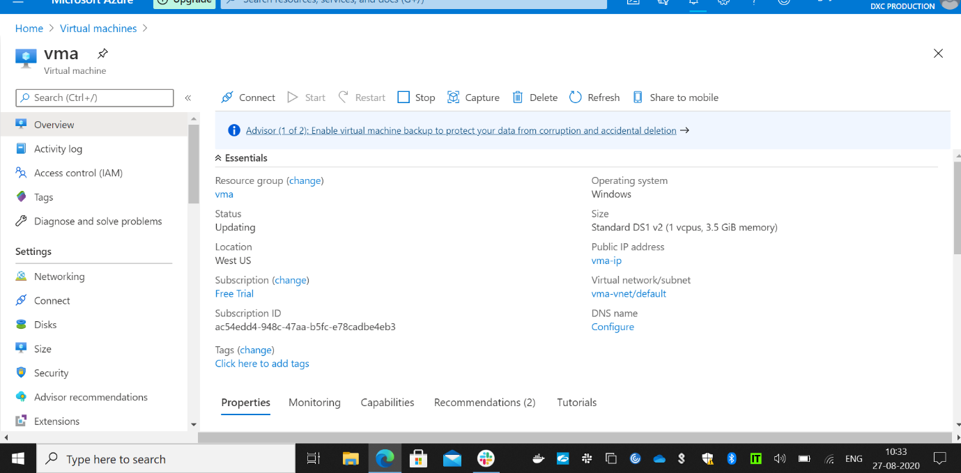

Created peering between the to networks

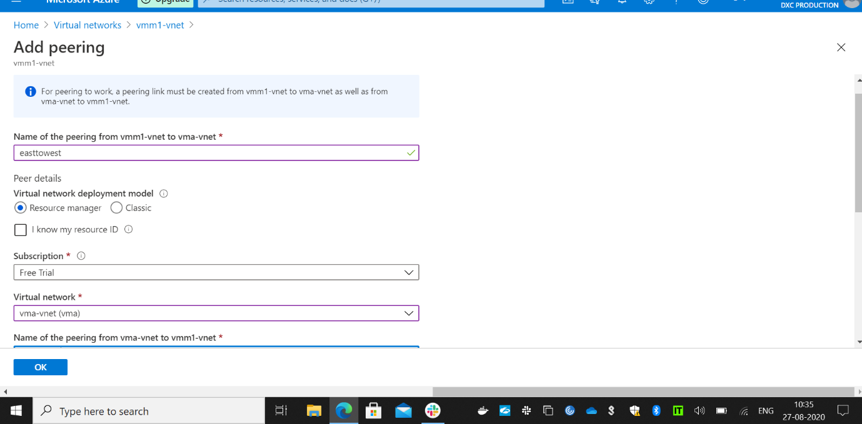

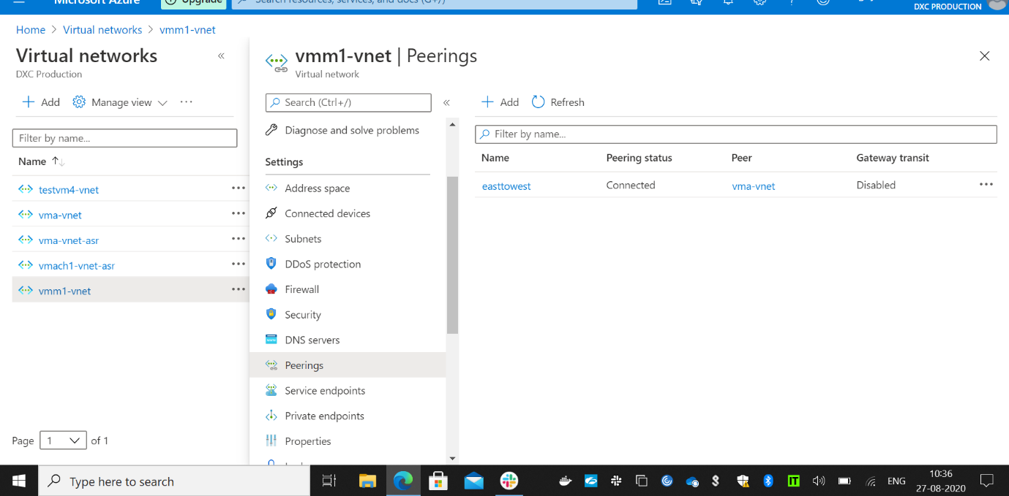

Opened vm which in East Asia

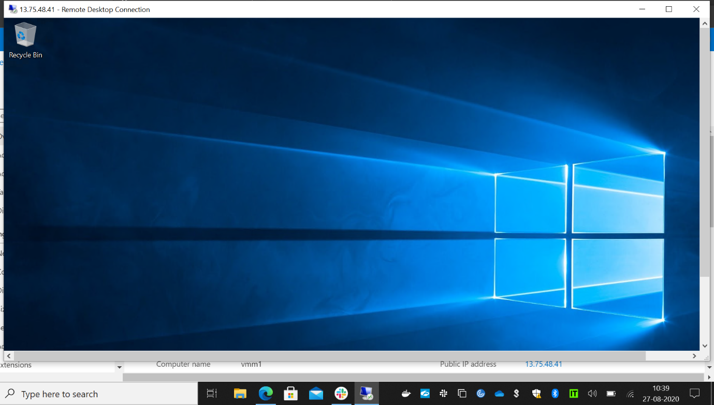

And trying to connect the vm which is another network and which is in west us by using the private ip.

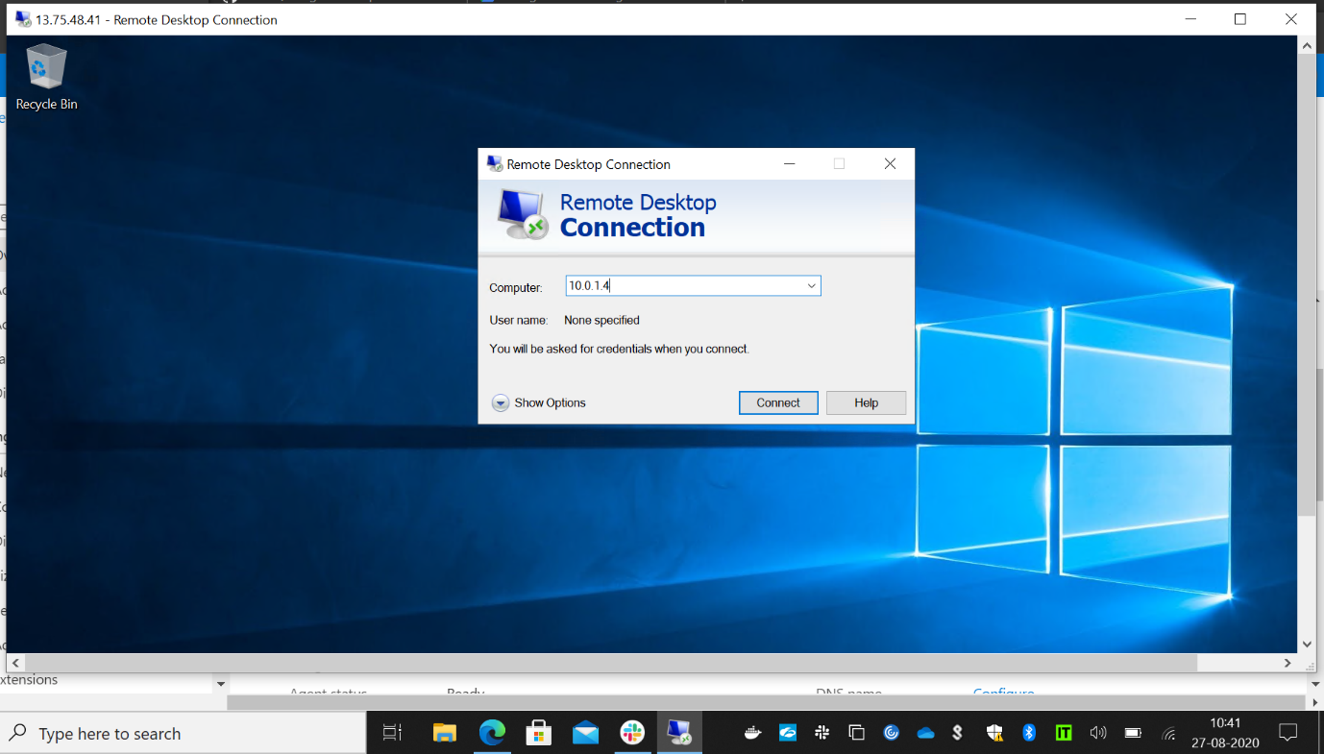

Here is the vm in another networked connected using the private ip.

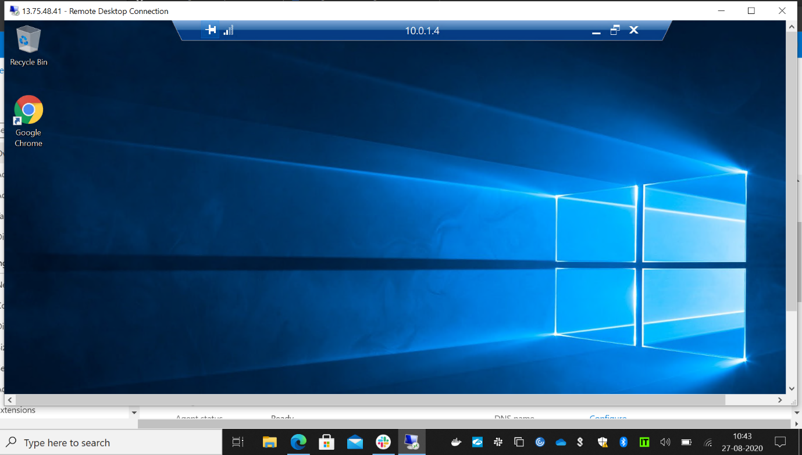

**3. Create a Point to site VPN in west us location and try connect from your location laptop to Azure datacenter**

Created a gateway subnet before creating the vpn gateway

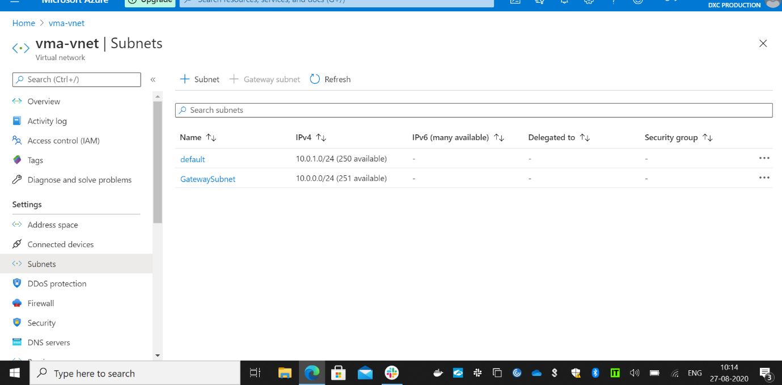

Created the vpn gateway in west us

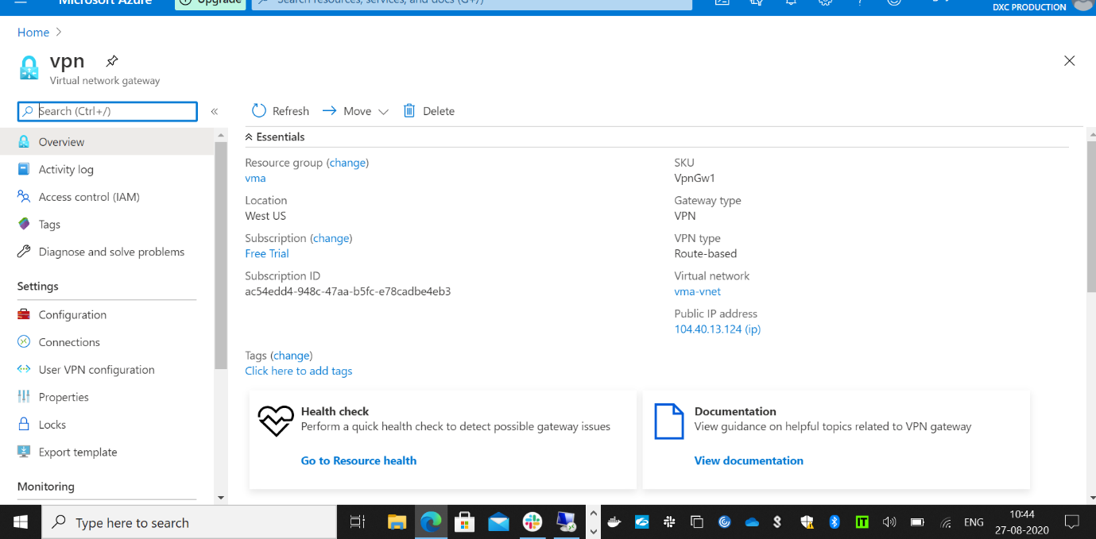

Connected the vpn 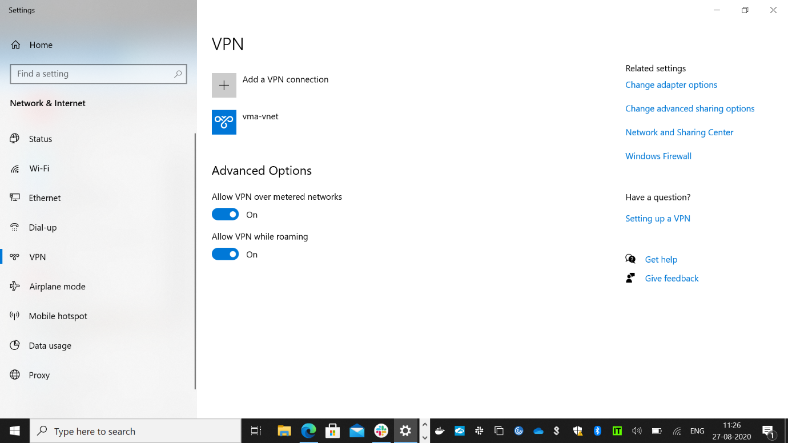

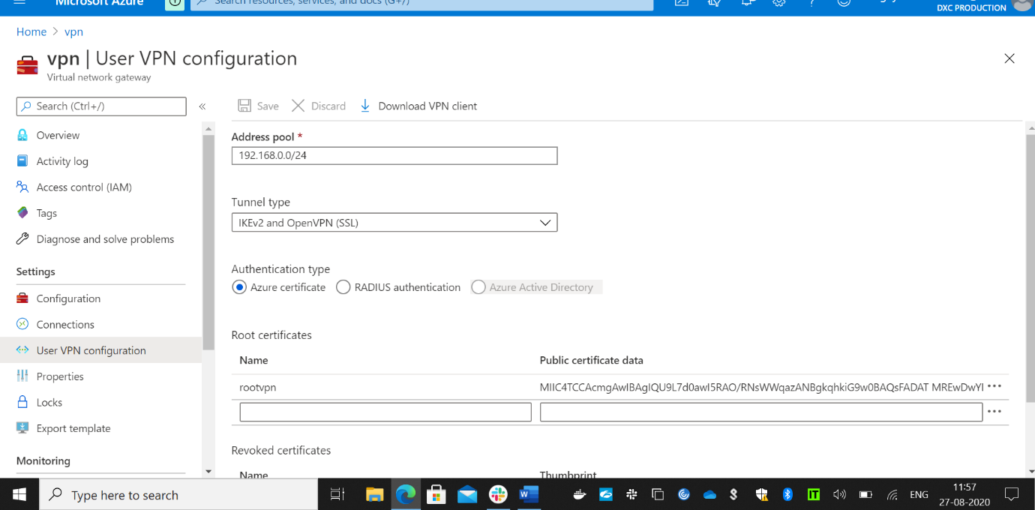

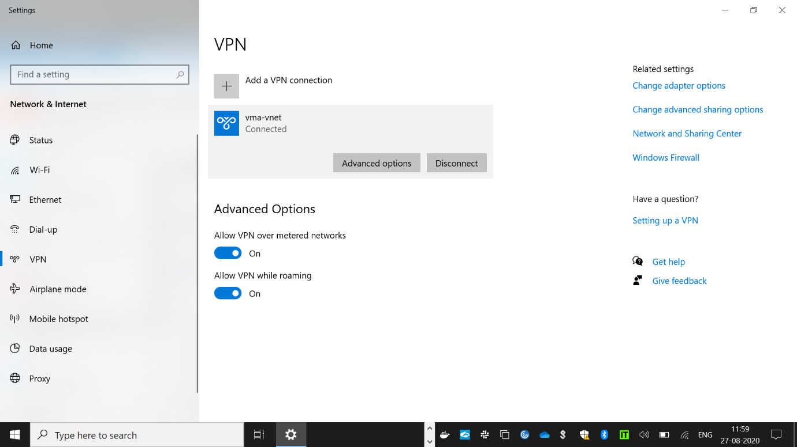

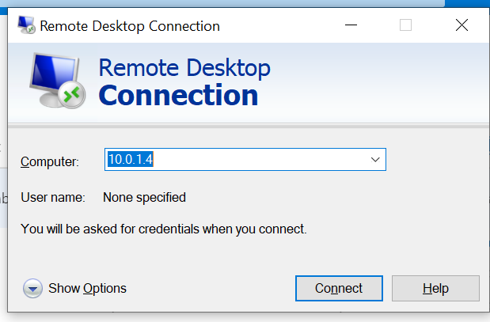

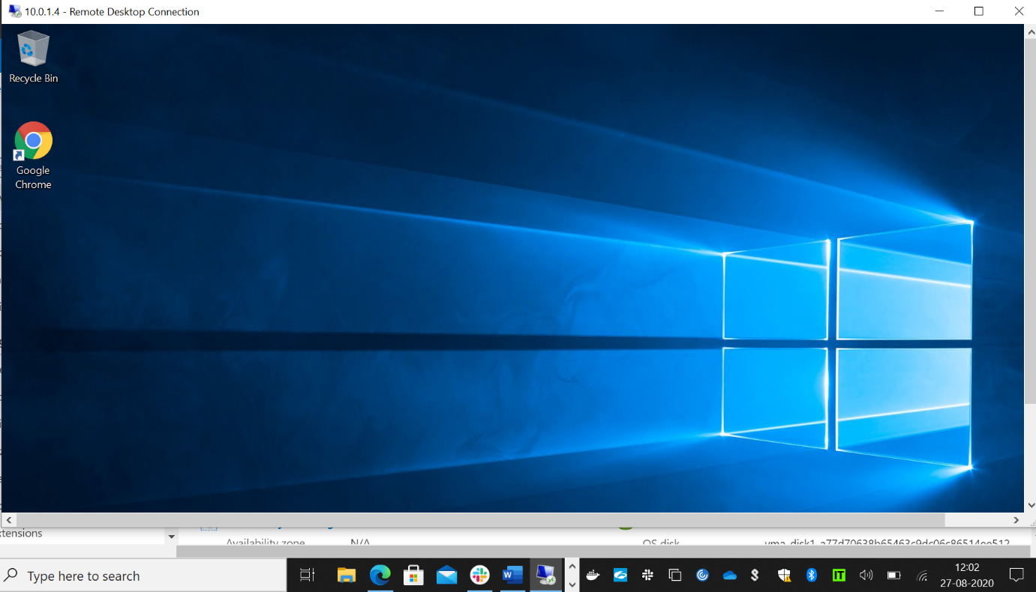

**4.** **Create a two web applications and put the apps under traffic manager with Priority routing method**

Create fisrt application

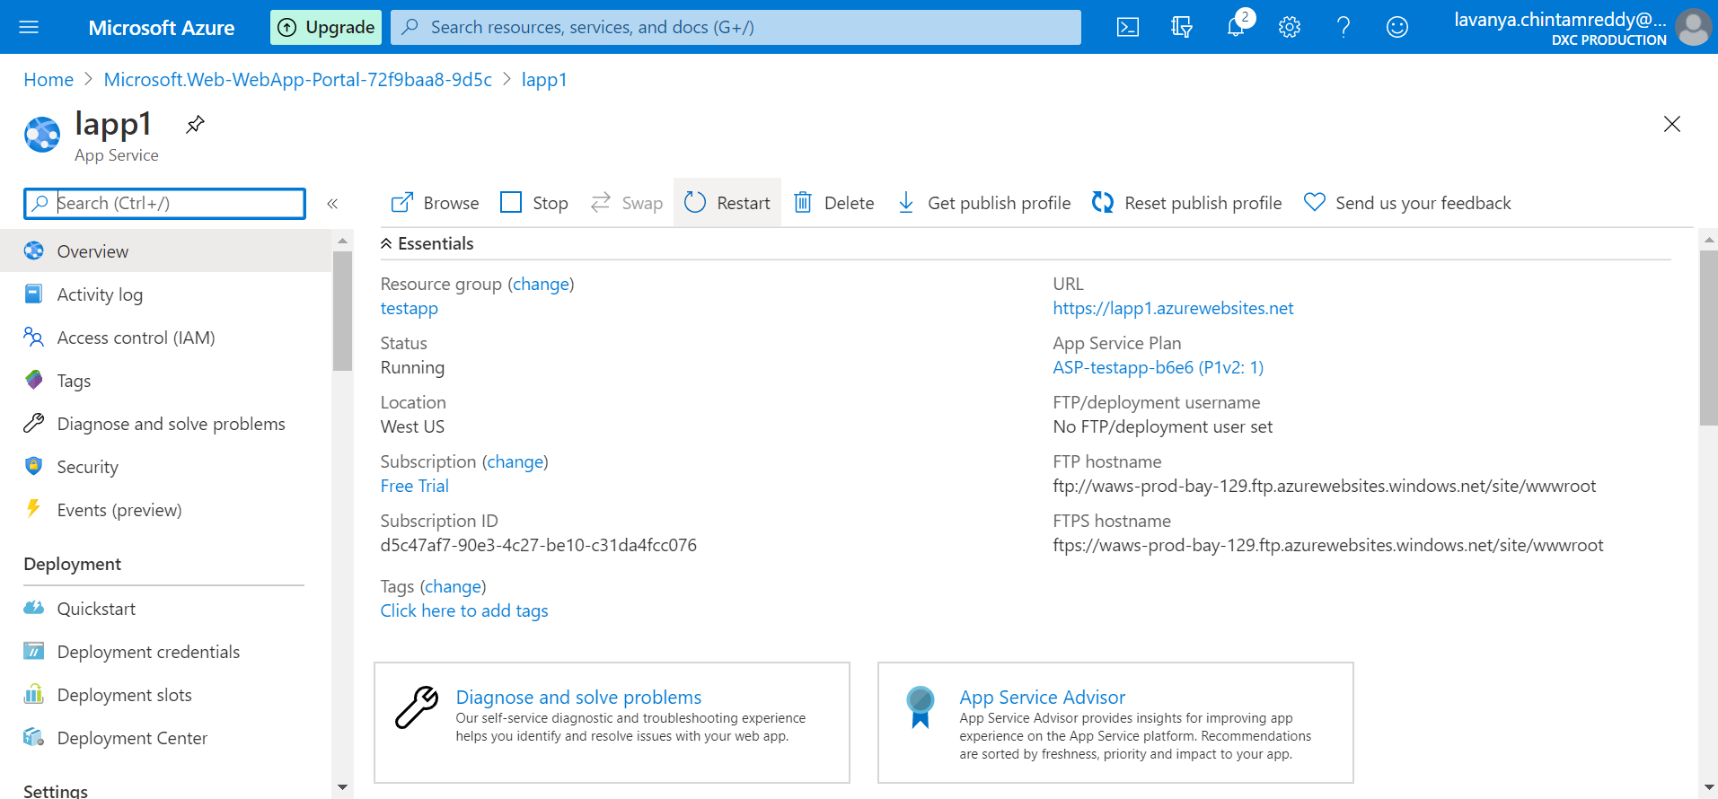

Create second web application

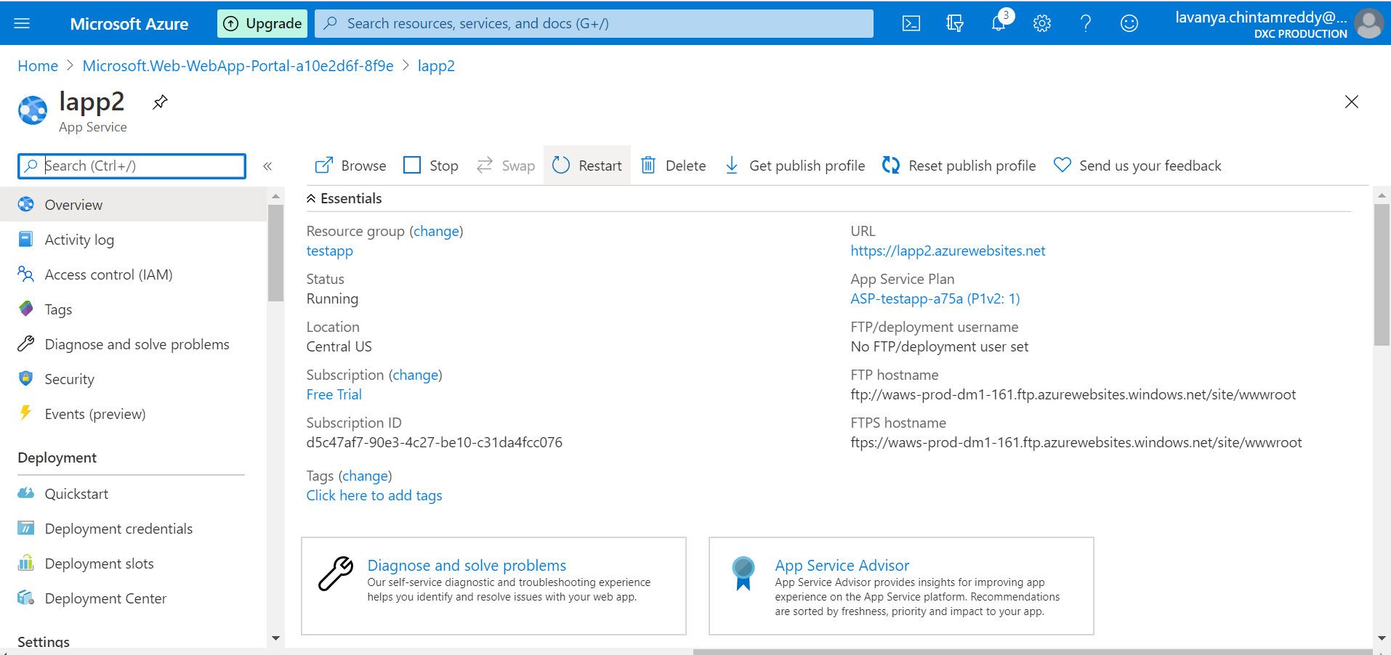

Put the first web application in traffic manager

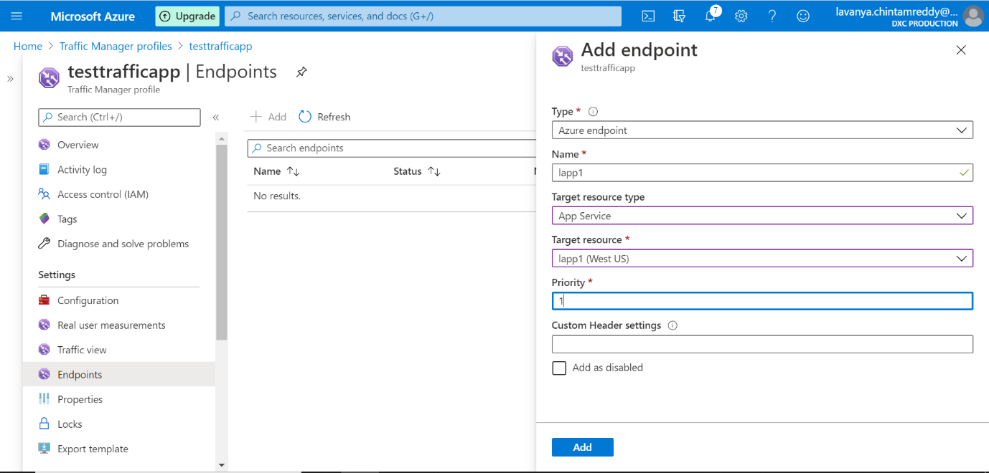

Put the second web application in traffic manager

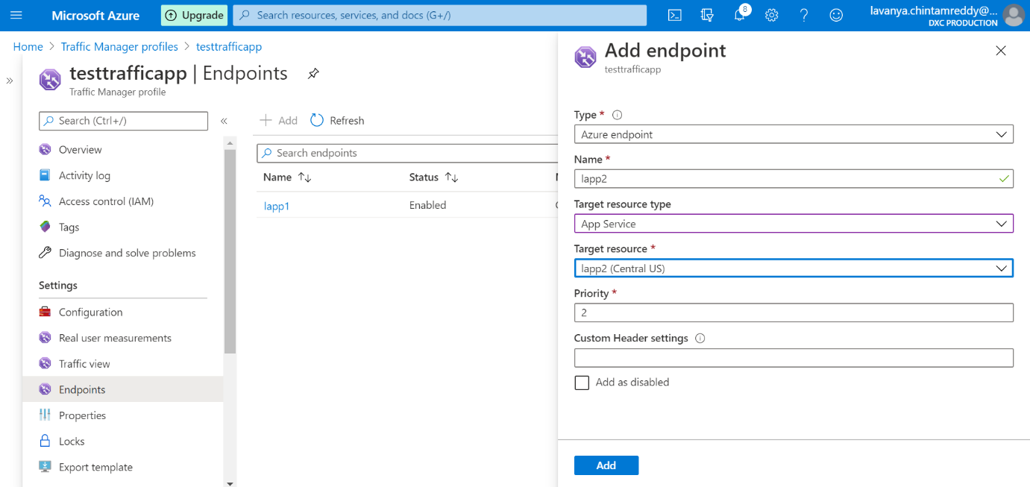

Put the two web applications under traffic manager with priority routing method

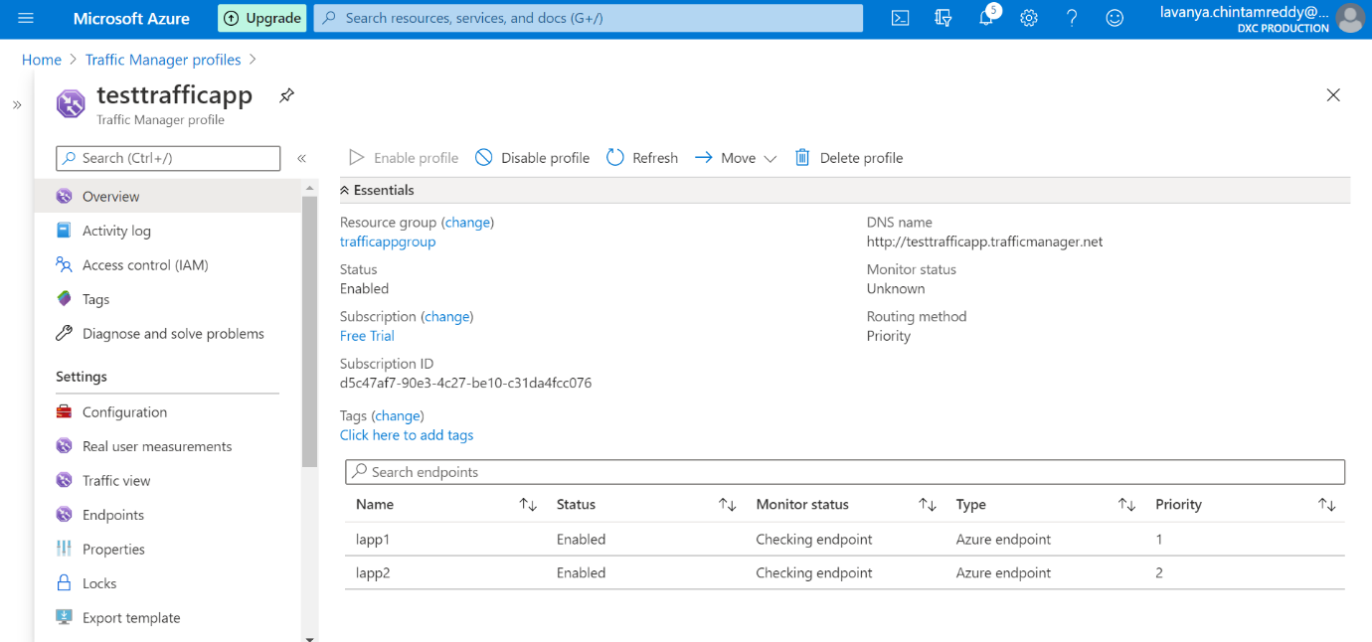

**5. Create a Backup solution for the Vm and assign a daily policy to the VM with 10 days retention period**

Add the vm to the recovery service vault for backup

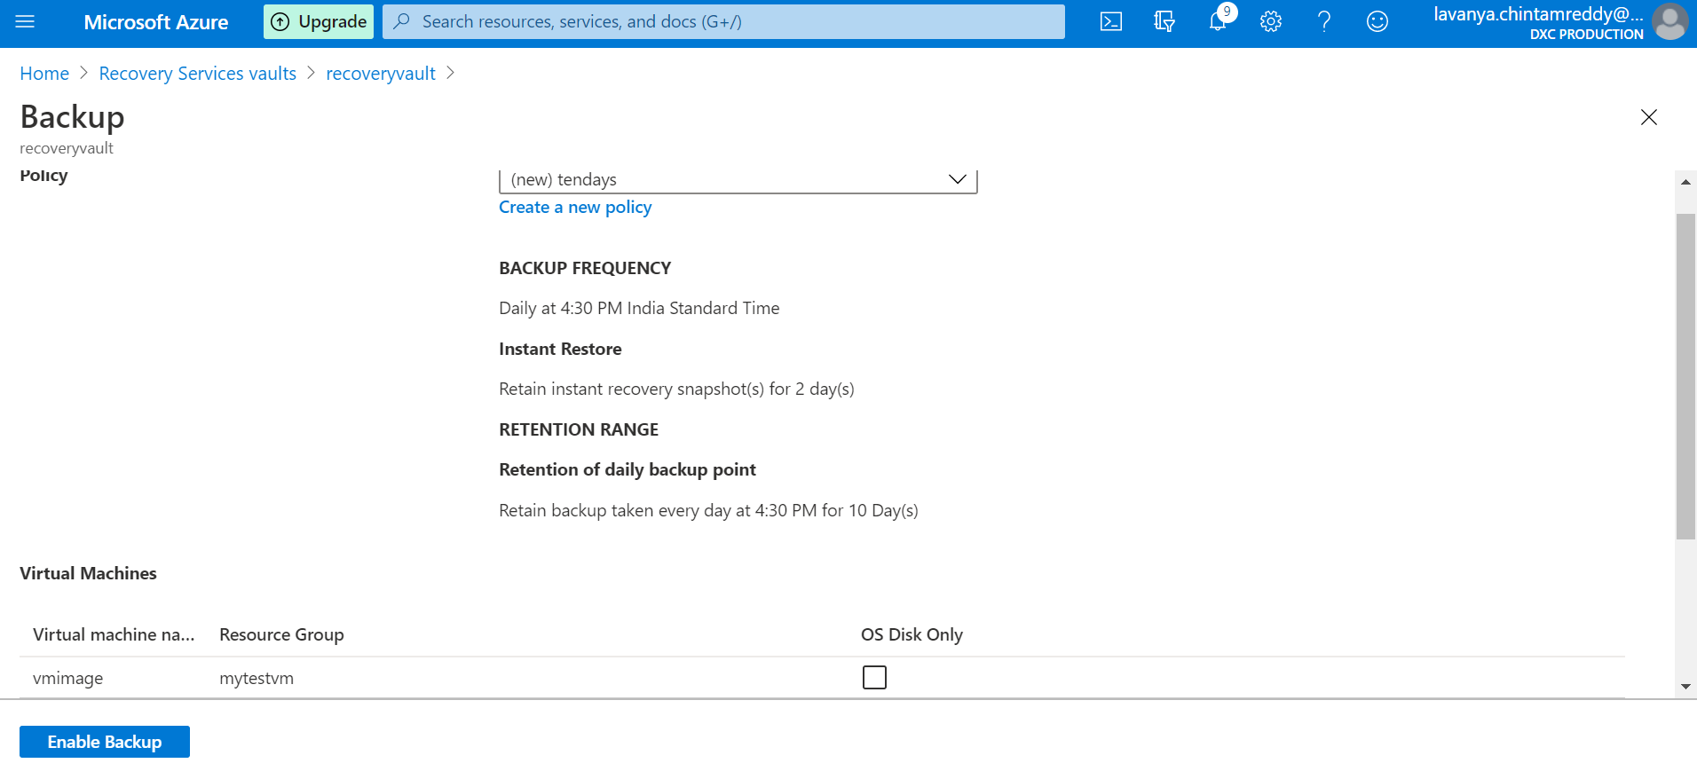

assign a daily policy to the VM with 10 days retention period

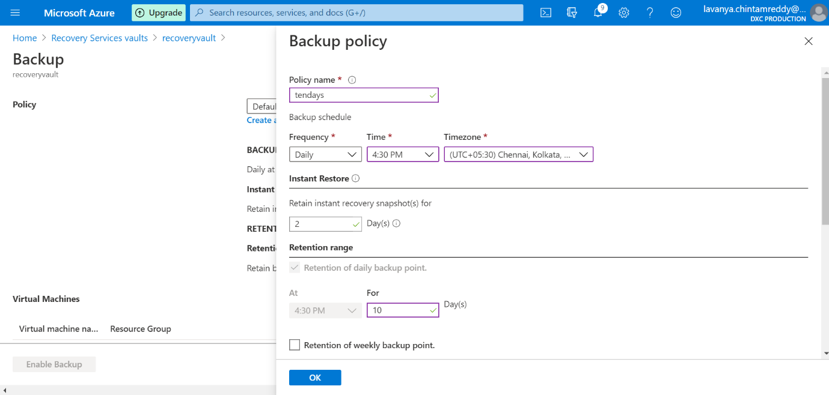

**6.Replicate the VM form west us to any location using failover**

Create the vm in west us

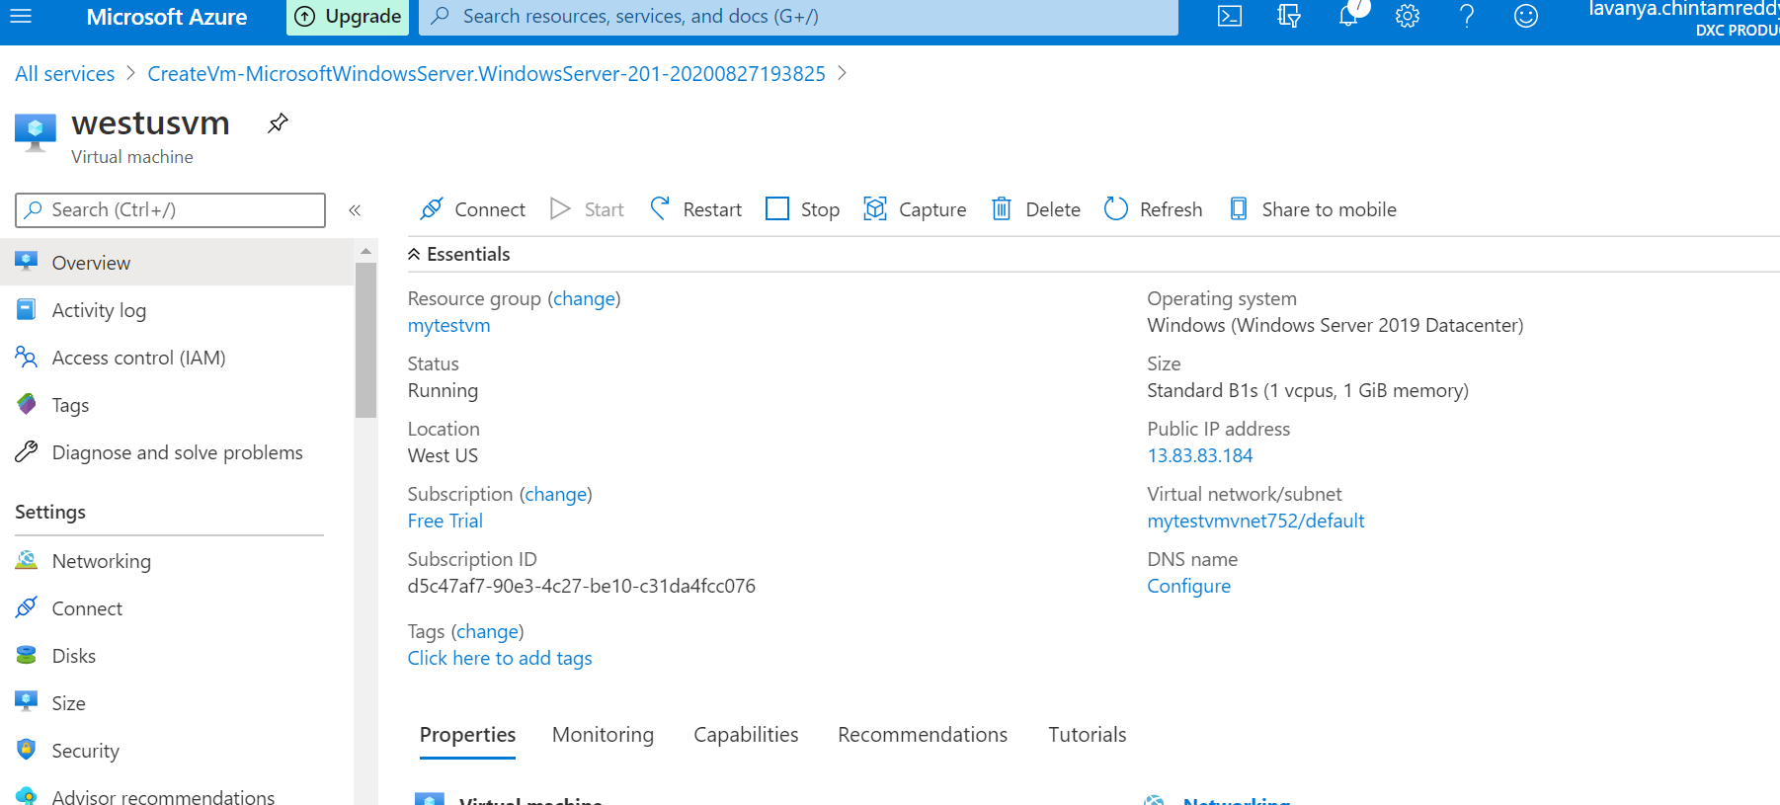

Start the replication

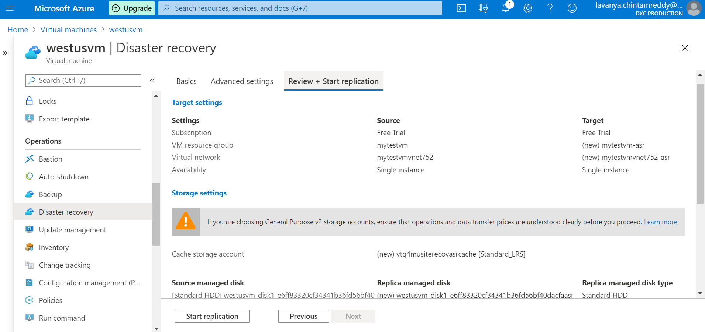

After replicating vm, the vm is showed in recovery vault replicated items

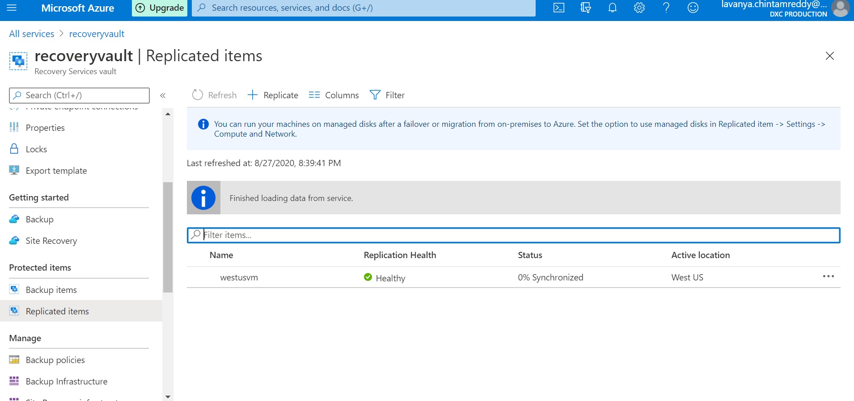

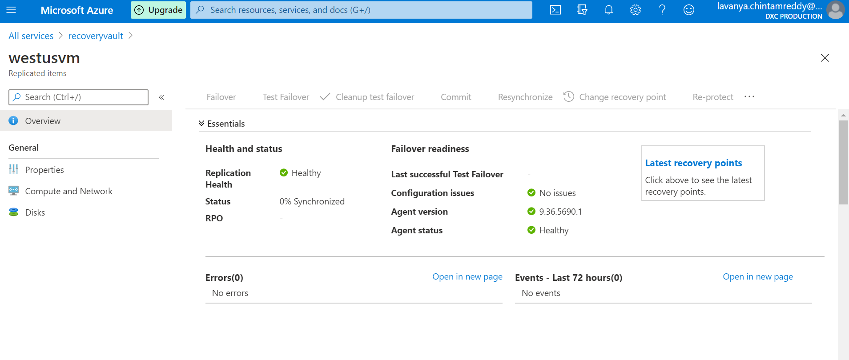

using failover to replicate the vm form west us

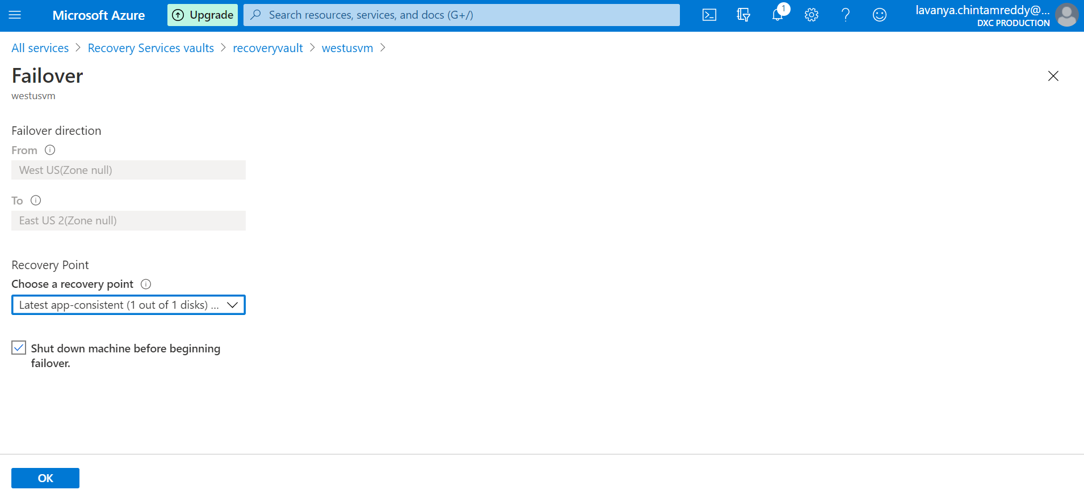

in this we see the replicated vm to another region

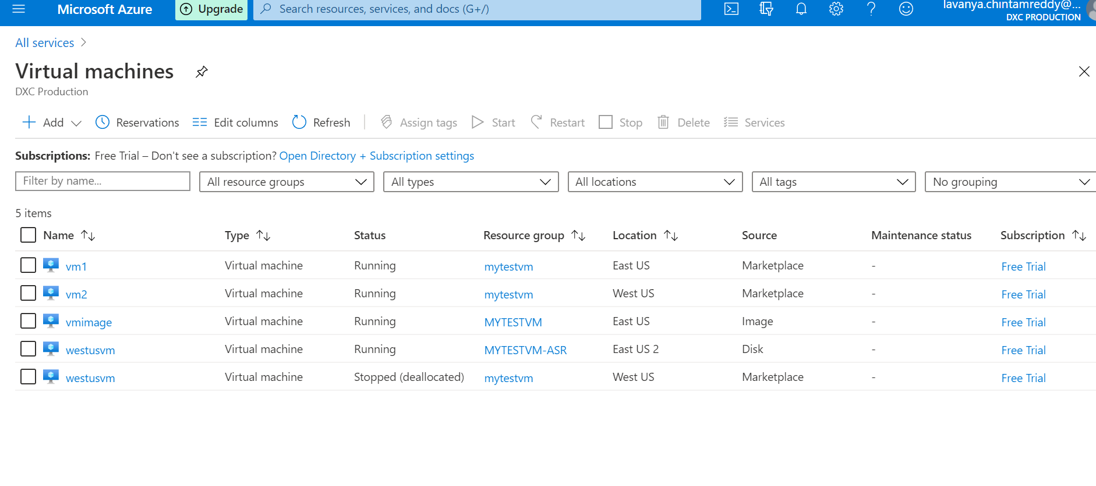

**7. Take a on-premises backup using backup agent and exclude test folder from any drive**

Backup scheduled for the folders E and F and excluded the folder F

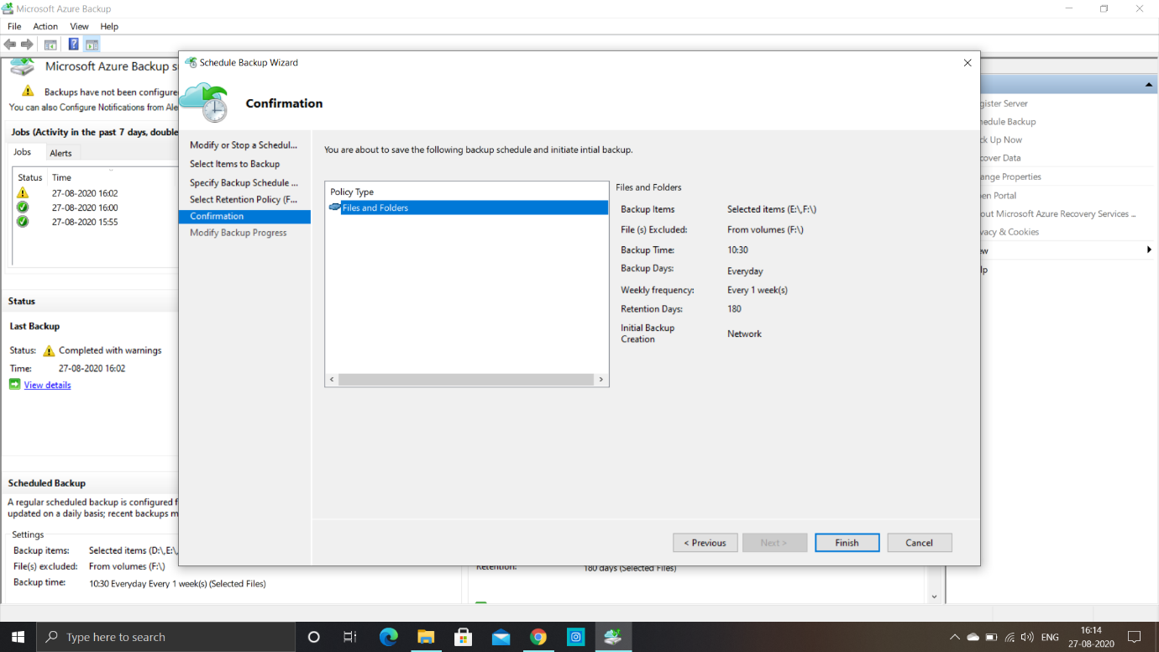

This is the folder F before deletion of items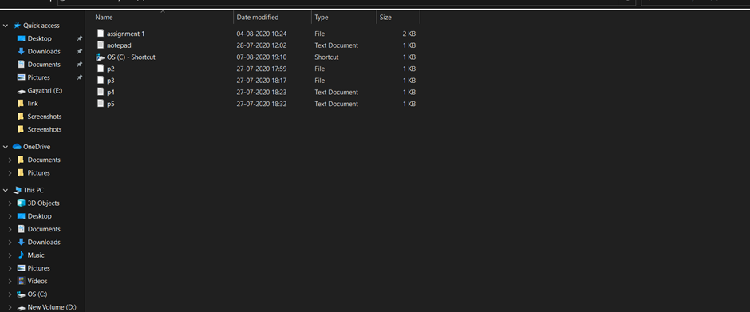

After deletion and backup we can see that the folder F files are not backuped as it is excluded from backup of files